CBOE
Test Plan
PITS 59125
SEDL 9470
Setup the following Firm Properties – use any market maker or login in place of the ones shown here

- Define ‘firm market maker trade notification parameter

- Define ‘firm mapping for floor trades’

You will need to login a SA GUI user and two Trader GUI users – One trader GUI will be the user that is sending in the customer order, the other will be the user receiving the MMTN, in the firm properties above, this would be user NYO.

Test Case 1: Send a simple order to par and bust the trade using the delete floor trade and MMTN ID.

- MM1, route a BUY 2500 @ MKT to your PAR workstation.
- Endorse the order on PAR to market maker DVS as shown below. Verify the firm number shown on PAR matches the firm number in the User Maintenance on SA GUI.
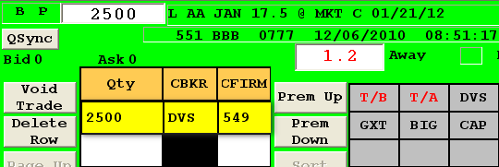
- Bust the MMTN received on the ‘Floor Trade Entry’ screen of MM2 (NYO).
- Verify that MM1 does not receive a bust notification in their status window
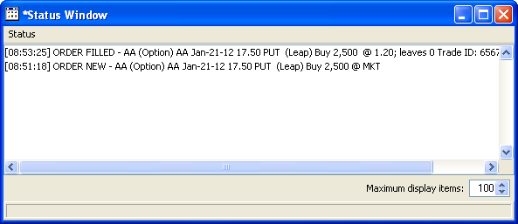

Test Case 2: Send a simple order to par and bust the trade using the SA GUI.

- MM1, route a BUY 2500 @ MKT to your PAR workstation.
- Endorse the order on PAR to market maker DVS as shown below. Verify the firm number shown on PAR matches the firm number in the User Maintenance on SA GUI.
- Bust the trade using the SA GUI.
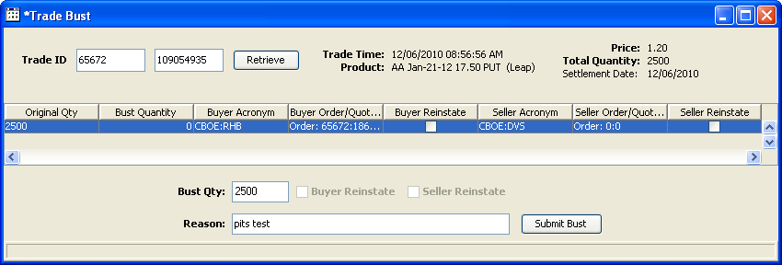
- Verify that MM1 does receive a bust notification in their status window
